Practical 1.2: SQL Exercise

An agricultural research lab uses the database below to record the results of its field trials. The tables are:

Location
Location ID | Exposure | Sunlight Percentage | Moisture Level
0 | East | .28 | .80
1 | North | .17 | .84
2 | West | .38 | .48
3 | South | .45 | .66

Technician
Technician ID | Technician Last Name
0 | Winograd
1 | Turing
2 | Savitch
3 | Wright

Crop
Crop ID | Crop Name | Optimal Sunlight Percentage | Optimal Moisture Level | Expected Harvest Weight (kgs)
0 | Carrot | .26 | .82 | .08
1 | Beet | .44 | .80 | .04
2 | Corn | .44 | .76 | .26
3 | Tomato | .42 | .80 | .16
4 | Radish | .28 | .84 | .02

Sowing (Crop, Technician and Location IDs are all foreign keys)
Crop ID | Technician ID | Location ID | Sowing Date | Seed Count
0 | 0 | 0 | 18-04-2005 | 28
0 | 1 | 1 | 14-04-2005 | 14
1 | 0 | 2 | 18-04-2005 | 36
2 | 1 | 3 | 14-04-2005 | 20
2 | 2 | 2 | 19-04-2005 | 12
3 | 3 | 3 | 25-04-2005 | 38
4 | 2 | 0 | 30-04-2005 | 30

Harvest (Crop, Technician and Location IDs are all foreign keys)
Crop ID | Technician ID | Location ID | Harvest Date | Harvest Unit Count | Harvest Total Weight
0 | 2 | 0 | 18-08-2005 | 28 | 2.32
0 | 3 | 1 | 16-08-2005 | 12 | 1.02
2 | 1 | 3 | 22-08-2005 | 52 | 12.96
2 | 2 | 2 | 28-08-2005 | 18 | 4.58
3 | 3 | 3 | 22-08-2005 | 15 | 3.84
4 | 2 | 0 | 16-07-2005 | 23 | 0.52

Write the SQL statement(s) needed to do each of the following. In some cases an example output is given to clarify the desired result.

- Create the tables shown above. Select data types and field names carefully. Implement all appropriate Foreign Key constraints.
- Populate your tables with the data values as shown. To save time, you may wish to use the script insertAgricultureData.sql available on the I: drive (adjust for your table names as required).
- Add a record for crop ‘Onion’ to the Crop table. Optimal sunlight percentage = 0.45; Optimal moisture level = 0.74 and Expected harvest weight = 0.19 kgs.
- Insert a record describing the following sowing event: Onion, Turing, North field, 32 seeds, 30th April, 2005. Assume that you know the ID values for Onion, Turing and the North field, and use them in your query.
For the remaining queries, assume that you do not know any of the ID values for Crop, Technician or Location. (That is, do not use an ID value in any WHERE clause.)
- Display all Carrot sowing events. For each, show the technician name (not the ID), the location exposure (not the ID), the date and the number of seeds planted.
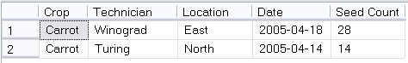

- Compute and display the total unit count and total weight of all the Corn harvestings. Two possible formats are:
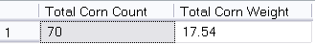
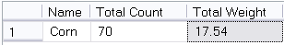

- Show the total weight for all crops in pounds. Display crops by name, not by ID number. (FYI: 1kg = 2.2 pounds.)
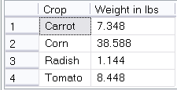

- Show all the harvests done by Savitch, with crop, date and unit count. The records should be sorted by date.

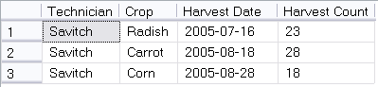

- Compute and display for each location, the difference between the amount of water available and the amount of water optimal, for carrots.

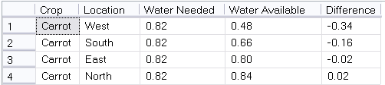

- Compute and display the number of days elapsed between the sowing date and the harvesting date for Tomatoes and Radishes (there is only one sowing and one harvesting for each of these two crops). The tidiest way to make this computation is using the T-SQL DATEDIFF(datepart, date1, date2) function.

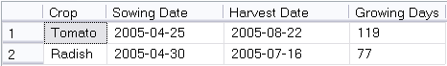

- The research team has decided to remove the beet crop from their study, and wish to delete all reference to beets from all tables. Beets are a member of the Plant relation, and serve as a Foreign Key in both the Sowing and Harvest tables. If we have not specified a delete action on those Foreign Key constraints, any attempt to delete the beet record from the Crop table will fail.
    - If you did not specify a delete action when you created your tables, use ALTER TABLE to do so now. Enforce a cascading delete.
    - Delete all mention of beets from your database.
    - Write appropriate queries to verify that beets are gone.

